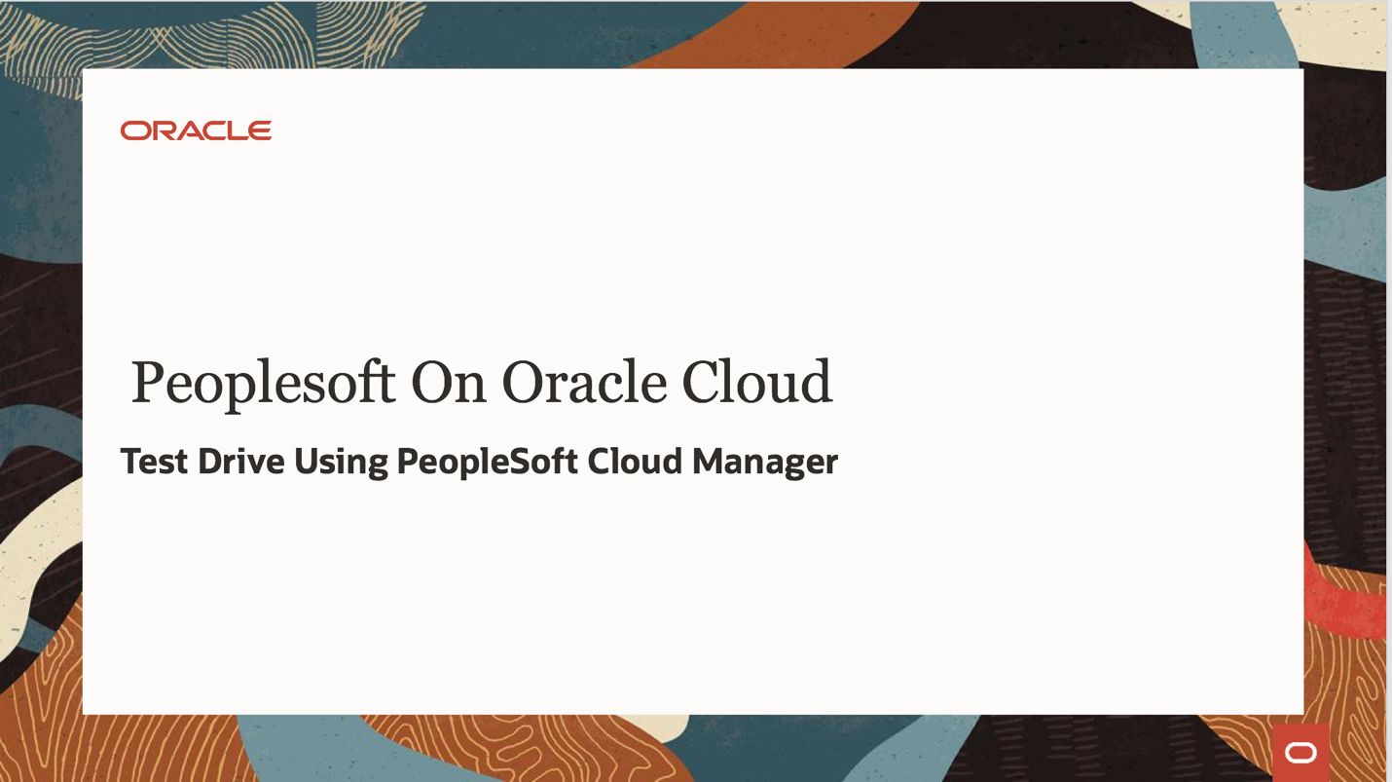

PeopleSoft Cloud Manager Hands-on Lab

Contents

1. Overview 3

2. Requirements 4

3. Prepare OCI tenancy and set up Cloud Manager 5

4. Configure Cloud Manager 14

5. Subscribe to download channels 17

6. Review and update a Topology 18

7. Create a new Environment Template 20

8. Create Environment 25

9. Additional Exercise – Provision Environments with Windows Clients 29

Appendix A – OCI Account URL and Resources 30

Appendix B – Accessing Cloud Manager using SSH 32

Appendix C – Network layout 32

Appendix D – Deployed OCI Resources 34

Appendix E – Provisioning Windows Instances 36

Appendix F – Creating a new subnet 37

## Overview

In this hands on lab, you will be able to bring up and configure a Cloud Manager instance in your tenancy, and provision a new PeopleSoft environment.

The lab can be divided into two sessions. In the first session, you will be able to –

1. Review the pre-requisites and set up your workstation/laptop (Section: Requirements)
2. Review VM shapes available in your account/tenancy (Appendix A)
3. Download and run the automation package to configure your tenancy, and deploy Cloud Manager (Section: Prepare OCI tenancy and set up Cloud Manager). The automation will –
   1. Create a user
   2. Create a group
   3. Create a compartment
   4. Create a OCI policy,
   5. Create network resources – VCN and subnets
   6. Subscribe to the Cloud Manager Marketplace image
   7. Create Cloud Manager instance
   8. Bootstrap install Cloud Manager application
4. Configure Cloud Manager Settings (Section: Configure Cloud Manager)
5. Create a File System for Download Repository
6. Subscribe to PeopleSoft Download Channels (Section: Subscribe to download channels)

Review Appendix C for details on the resources created by deployment automation. This session should take about 90 minutes approximately. The last step, when you subscribe to download channels, time taken for downloads to complete depends on network speed and the number of subscribed download channels. If only one application channel and one PeopleTools channel with only the latest patch is subscribed, then downloads should complete in about 60 to 90 minutes depending on the download speed.

In session two, which should take you approximately 60 to 75 minutes, you will be able to create a Topology, an Environment Template and provision a new PeopleSoft environment.

## Requirements

Time: 10 mins

1. User already has a tenancy with Administrator user access.
2. My Oracle Support credentials
3. Minimum resources in Home region of the tenancy
   1. 4 x VM shapes (VM.Standard2.2 or VM.Standard2.1, VM.StandardE2.2 or VM.StandardE2.1)
   2. 1 TB block storage
4. User brings their own Windows workstation/laptop to access OCI console, PSFT Cloud Manager and provisioned instances.
5. User has access to a Windows workstation/laptop with the following installed:
   1. [Git Bash for Windows](https://git-scm.com/download/win) - <https://git-scm.com/download/win>
   2. A web browser to connect to OCI web console and Cloud Manager PIA – Firefox or Chrome recommended.

## Prepare OCI tenancy and set up Cloud Manager

Follow the steps outlined below to configure your tenancy.

Time: 80 mins

1. Ensure Git Bash is installed on your laptop/workstation.
2. Download automation scripts bundle ‘psftcm-setup.zip’ - [**DOWNLOAD**](https://objectstorage.us-ashburn-1.oraclecloud.com/p/3NjQSZOmGRw4GpltHFRZu0ZQhp_172UPfMgW6Mf2ka4/n/intpsftengt/b/release/o/psftcm-setup-2.1.zip)
3. Extract psftcm-setup-3.0.zip to a new folder on the laptop/workstation. Let’s call it ‘psftcm-setup’. Below are the contents in the zip file.

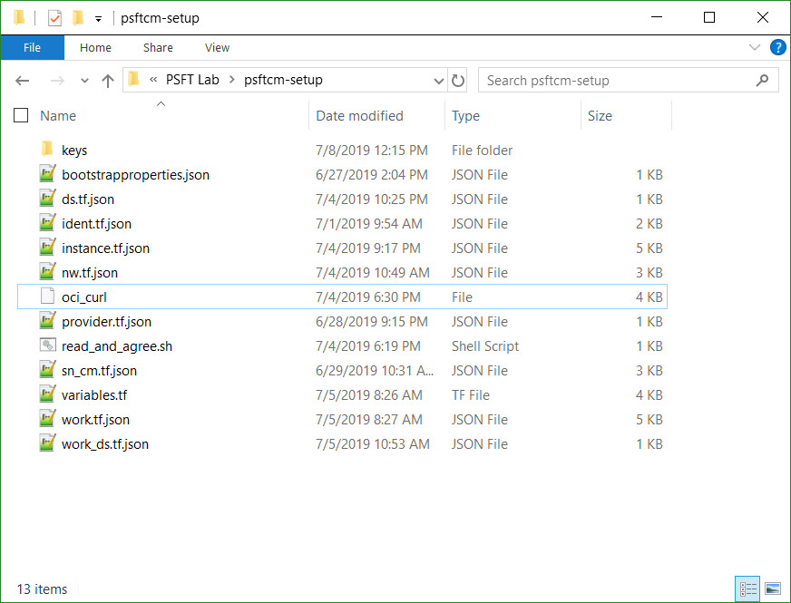

1. Launch Git Bash command line and navigate to the newly extracted folder – ‘psftcm-setup’.
2. Change directory to “keys” folder, under the extracted folder

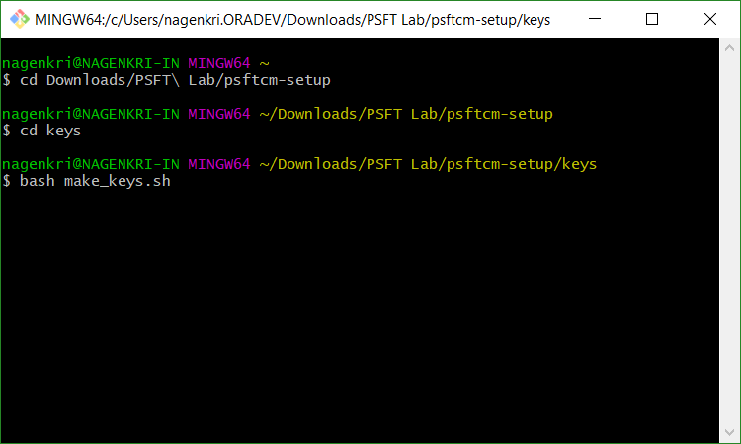

1. Run the script “bash make_keys.sh”

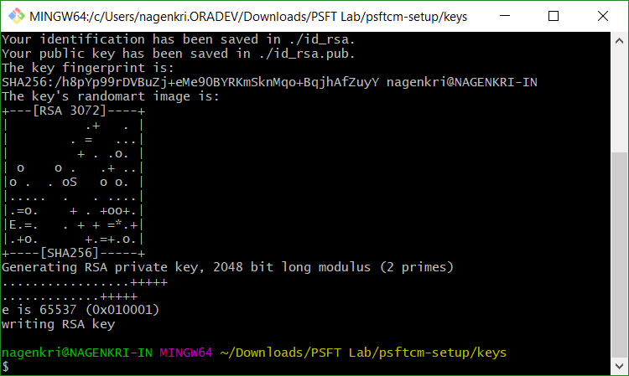

1. Below set of key files are generated. There are two sets of keys –
2. API Signing keys – **api_key** and **api_key.pub**
3. SSH key pair – **id_rsa** and **id_rsa.pub**

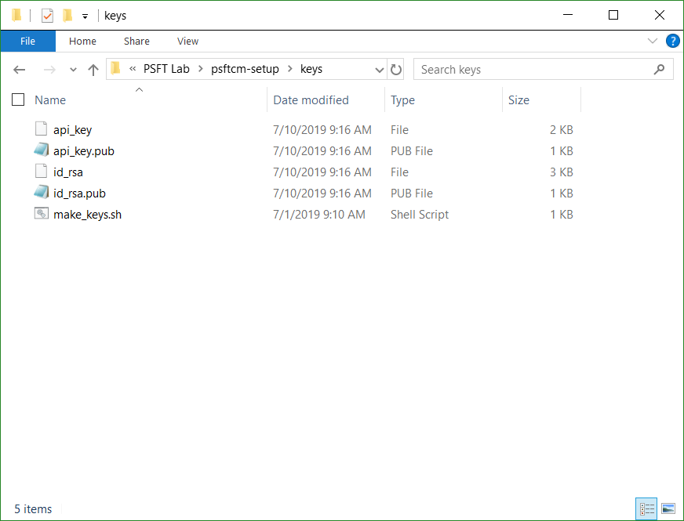

1. Zip the contents in the extracted folder into a new zip file. Let’s call it ‘psftcm-setup.zip’. Note – The zip file should be created as shown below. Select all files 🡪 right-click 🡪 Send to 🡪 Compressed folder. Rename the zip file.

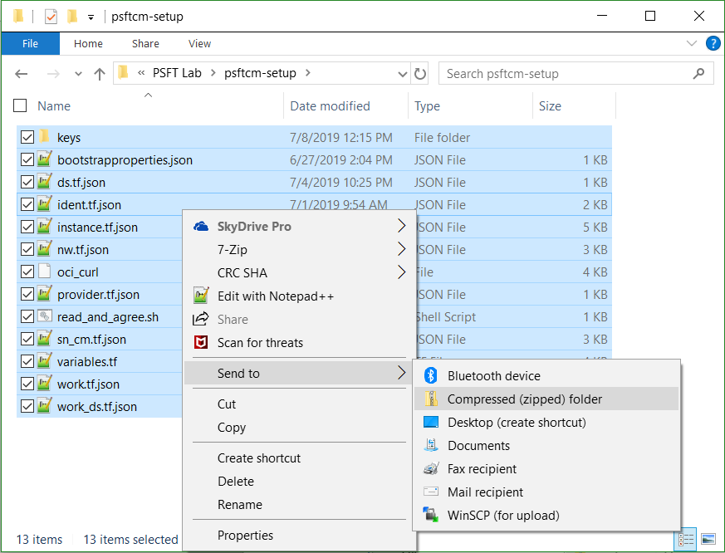

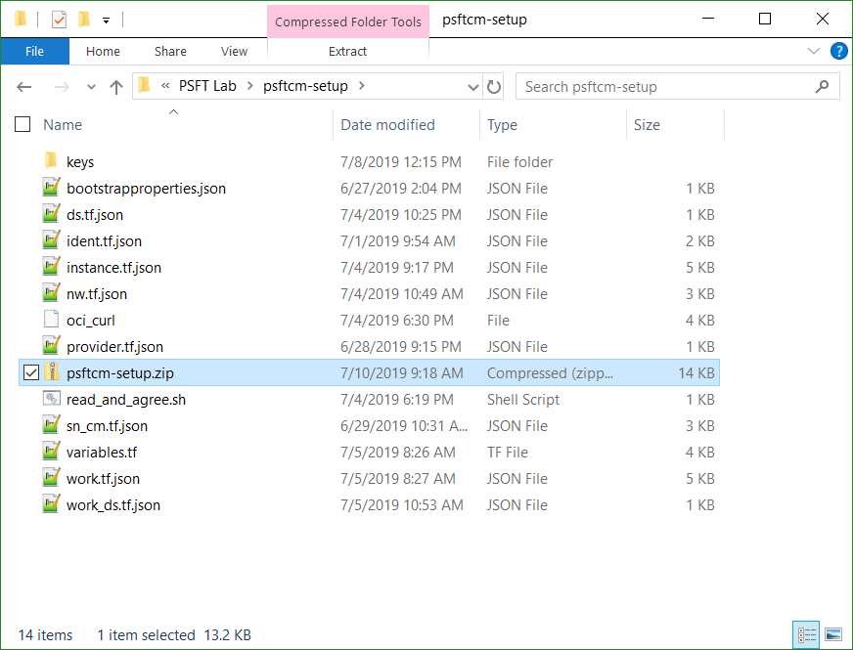

1. In a browser, launch the OCI console and navigate to Resource Manager 🡪Stacks. Refer Appendix A for details on how to get OCI console URL.
2. Add a new stack by uploading the newly created psftcm-setup.zip file.

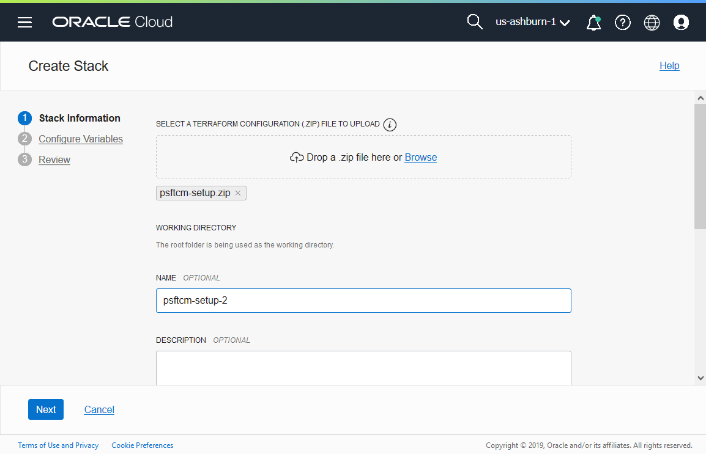

1. Click Next. You have to select an Availability Domain. For the other variables, the default values should work in most cases. Configure variables only if required. If your tenancy has a different set of shapes, or they are allocated across different ADs, only then update the values. Otherwise, the defaults should work.

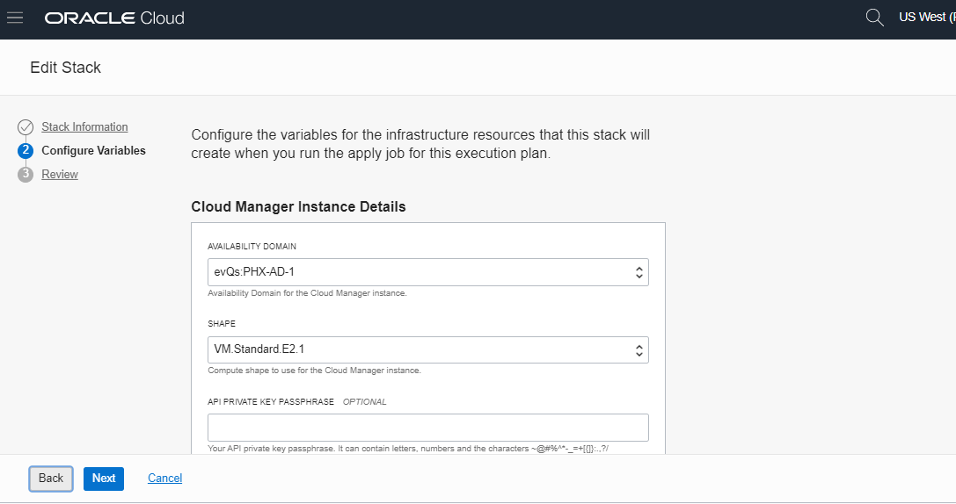

Below table summarizes the inputs in Configure Variables page.

|  |  |
| --- | --- |
| **Attribute** | **Value** |
| AVAILABILITY DOMAIN | Availability Domain for CM instance and for provisioning PSFT environment |
| PRIVATE_KEY_PASSWD | - |
| SHAPE | VM.Standard2.2  (Modify in case your tenancy does not have this shape) |
| DB CONNECT PASSWORD | peop1e |
| ACCESS PASSWORD | SYSAD123 |
| DB ADMIN PASSWORD | Passw0rd# |
| CLOUD MANAGER ADMINISTRATOR PASSWORD | Passw0rd |
| INTEGRATION GATEWAY USER PASSWORD | Passw0rd |
| WEBLOGIC ADMINISTRATOR USER PASSWORD | Passw0rd |
| WEB PROFILE USER PASSWORD | PTWEBSERVER |
| DOMAIN CONNECT PASSWORD | Passw0rd123 |

1. Click Next and review your inputs.

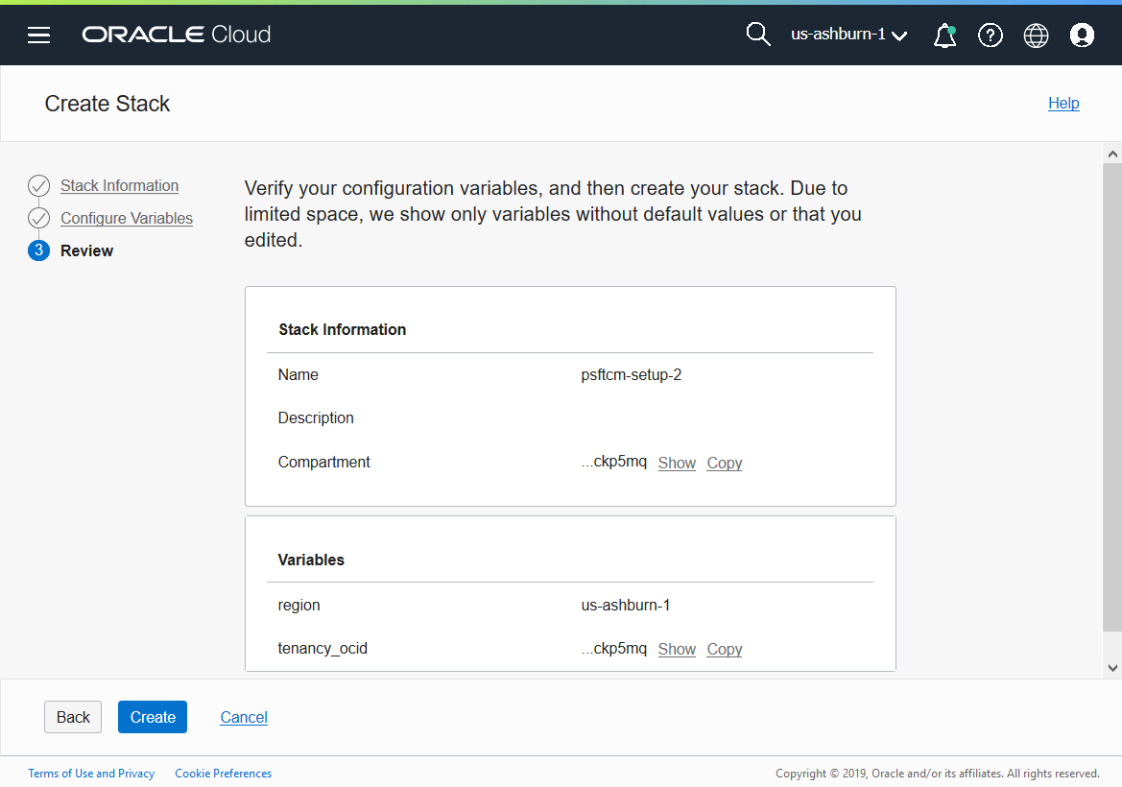

1. Click Create. This will add a new stack and open the stack details page.
2. On the stack details page, under “Terraform Actions”, click Plan.

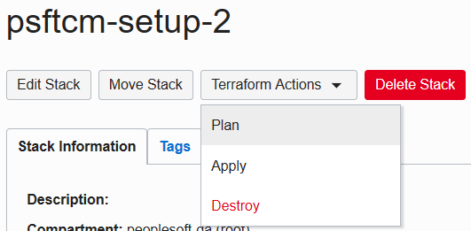

1. After the Plan completes successfully, run Terraform Apply.

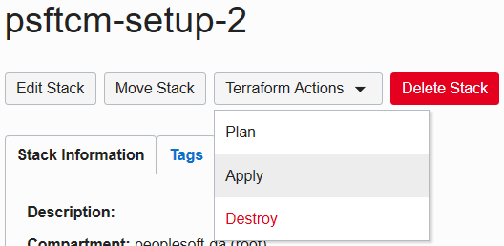

1. Terraform Apply job is a long running process. After it completes, the output from this job will have the IP address and PIA URL of CM instance. To obtain those details, click on the Job name.

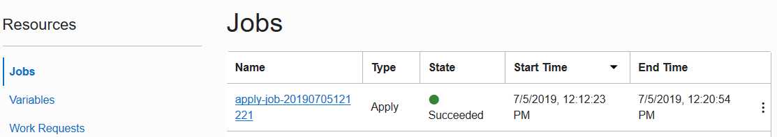

1. On the job details page, click on Output link under Resources.

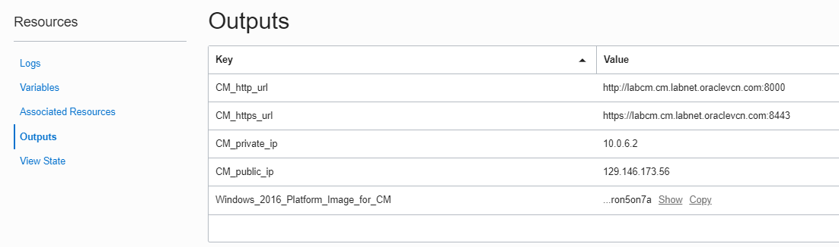

1. Make a note of the **Windows_2016_Platform_Image_for_CM** value. This OCID will be required in the next section.
2. Make a note of **CM_public_ip** and **CM_http_url**.
3. Add an entry to **C:\Windows\System32\drivers\etc\hosts** entry on your laptop/workstation as shown below. Use the hostname value for attribute **CM_http_url**.
   1. Open Windows Search “Notepad”. Right Click on Notepad and open as Administrator.

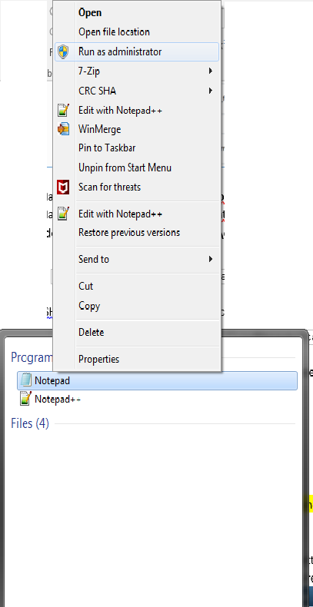

* 1. Go to File 🡪Open 🡪 **C:\Windows\System32\drivers\etc\hosts**, and append below entry

|  |
| --- |
| 129.213.145.213 labcm.cm.labnet.oraclevcn.com |

1. SSH into Cloud Manager instance to check status of deployment. Monitor Cloud Manager bootstrap installation using below command.

|  |
| --- |
| $ tailf /home/opc/bootstrap/CloudManagerStatus.log |

Refer Appendix A for details on how to SSH into Cloud Manager instance.

1. While Cloud Manager is being installed, review Associated Resources for the list of all resources created by automation. Refer Appendix D for more details.
2. After Cloud Manager bootstrap is complete, the CloudManagerStatus.log will show the following messages.

|  |
| --- |
| The PeopleSoft Environment Setup Process Ended.  CM installed successfully  Cloud Manager PIA URL: <http://labcm.cm.labnet.oraclevcn.com:8000>  Cloud Manager PIA SSL URL: <https://labcm.cm.labnet.oraclevcn.com:8443> |

1. Launch a browser to access your Cloud Manager PIA URL (CM_http_url) – <http://labcm.cm.labnet.oraclevcn.com:8000>

To login, use the username CLADM and password that was provided for input parameter OPR_PWD.

## Configure Cloud Manager

Time: 20 mins

**Configure Cloud Manager Settings:**

1. Navigate to Cloud Manager Dashboard | Cloud Manager Settings | Cloud Manager Settings
2. Update My Oracle Support (MOS) Credentials. This is required to download DPKs and PRPs automatically.

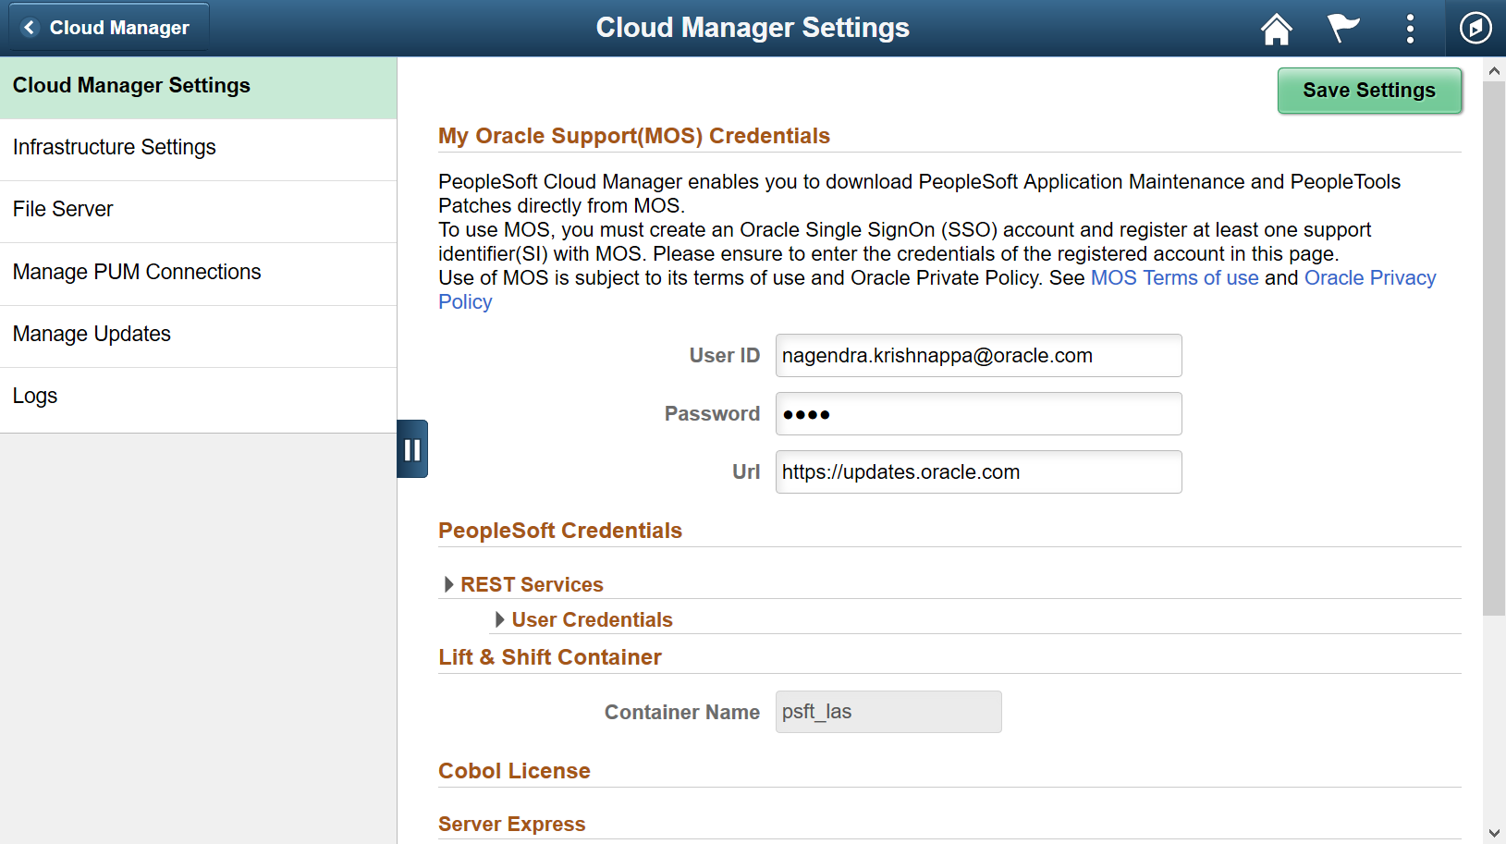

1. Navigate to Infrastructure Settings and update Operating System Images. For Linux, enable “Marketplace Image” radio button

and choose the latest version from the displayed list.

For Windows image, use the value of “Windows_2016_Platform_Image_for_CM” displayed earlier in the Outputs section of the stack.

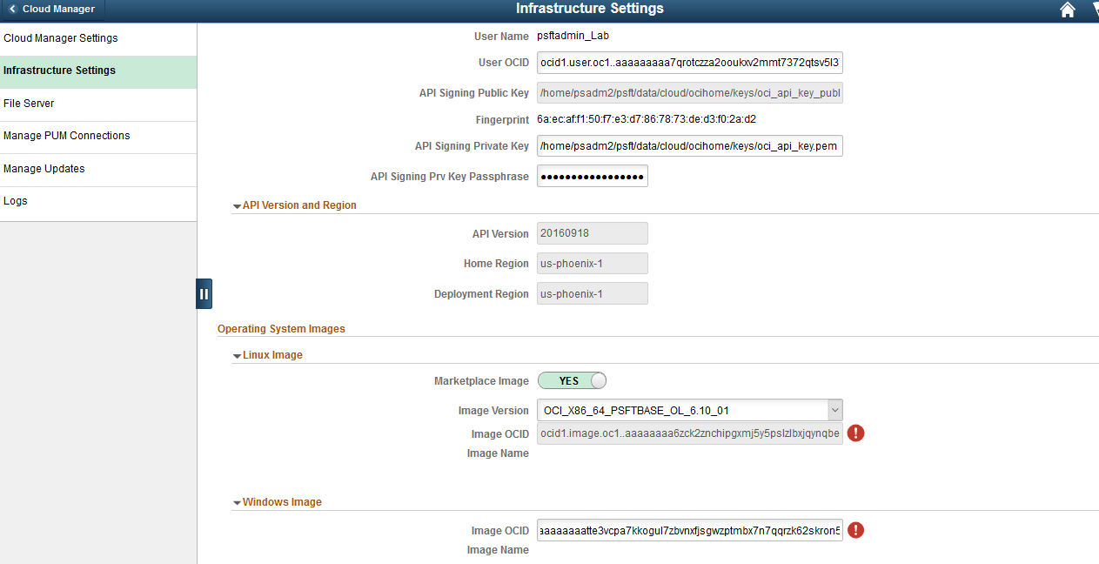

1. Click ‘Save’ to save the configuration.
2. Click ‘Refresh OCI Metadata’ button on top of the page and wait for few minutes
3. Next, navigate to File Server tab. Accept the defaults. For Mount Target, type “lab”

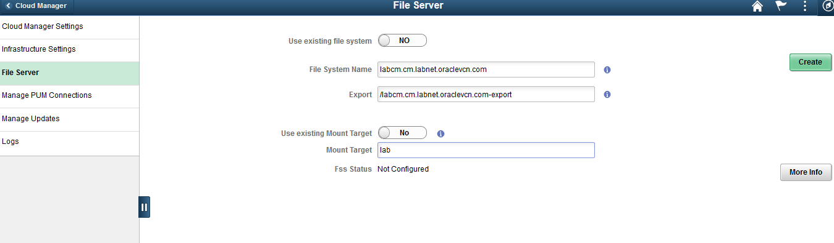

1. Click Create. This action will create a file server in a few minutes.
2. Wait until the file server status shows ‘FSS **Configured**’, and then the system is ready for downloads.



## Subscribe to download channels

Time: Depends upon download speed and number of subscribed channels. Around 60 mins for this example.

1. Navigate to Cloud Manager Dashboard 🡪 Repository 🡪 Download Subscriptions
2. Go to the Unsubscribed tab
3. On a download channel of your choice, click on related actions menu and click Subscribe. E.g, HCM_92_Linux. Monitor the Logs page to check for progress.

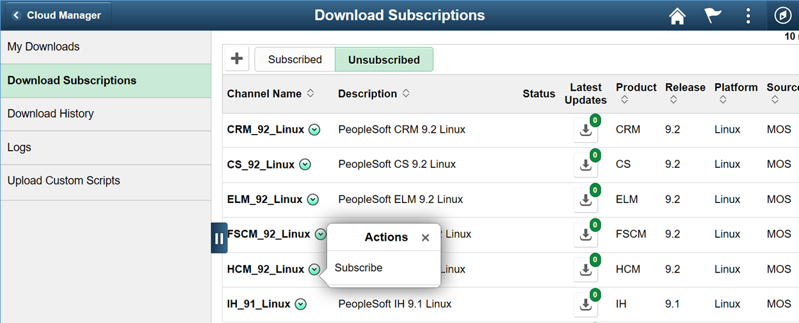

## Review and update a Topology

Time: 10 mins

1. Navigate to Dashboard | Topology | PUM Fulltier topology. This topology will be used to create a new environment.

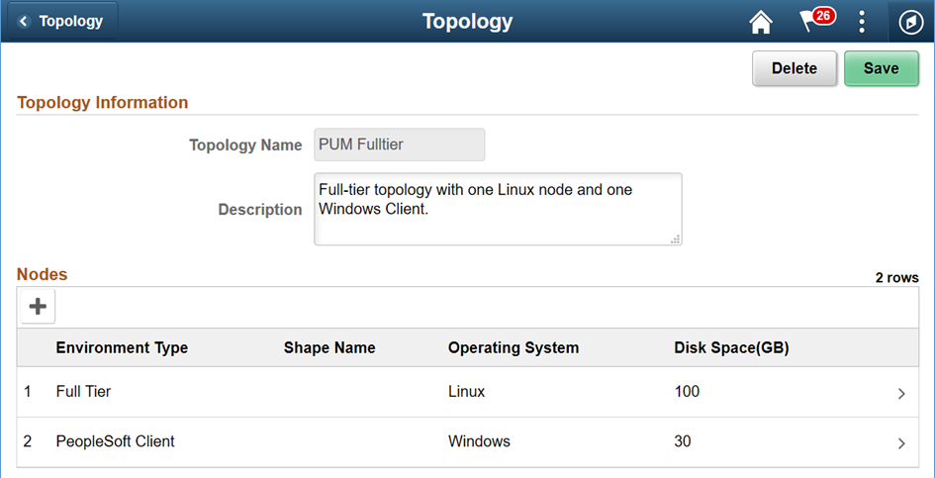

1. Review the nodes and update the Shapes. Click Full Tier node and select a shape that is available in your AD 2. In this case, select VM.Standard2.1 or VM.Standard2.2. Review the available shapes in your AD as explained in Appendix A.

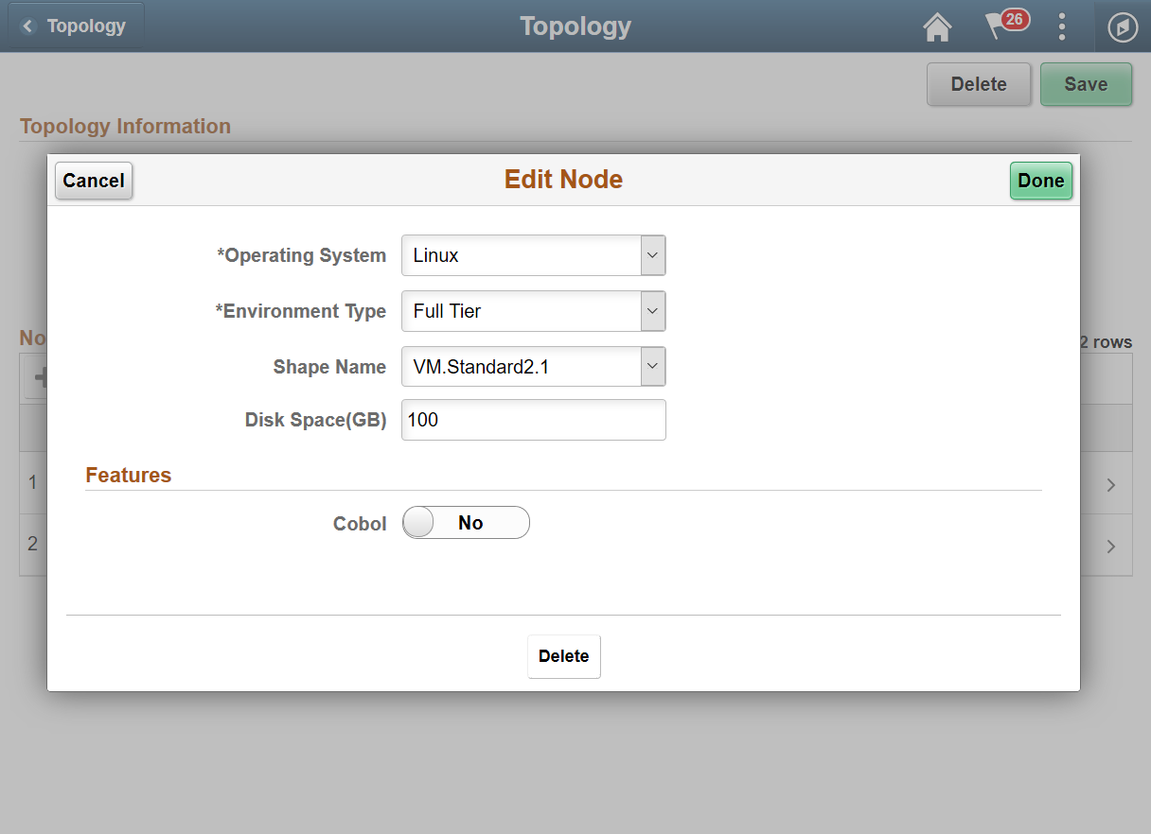

1. Delete the Windows node from the topology. Click ‘Delete’ on the page shown below and save the topology.

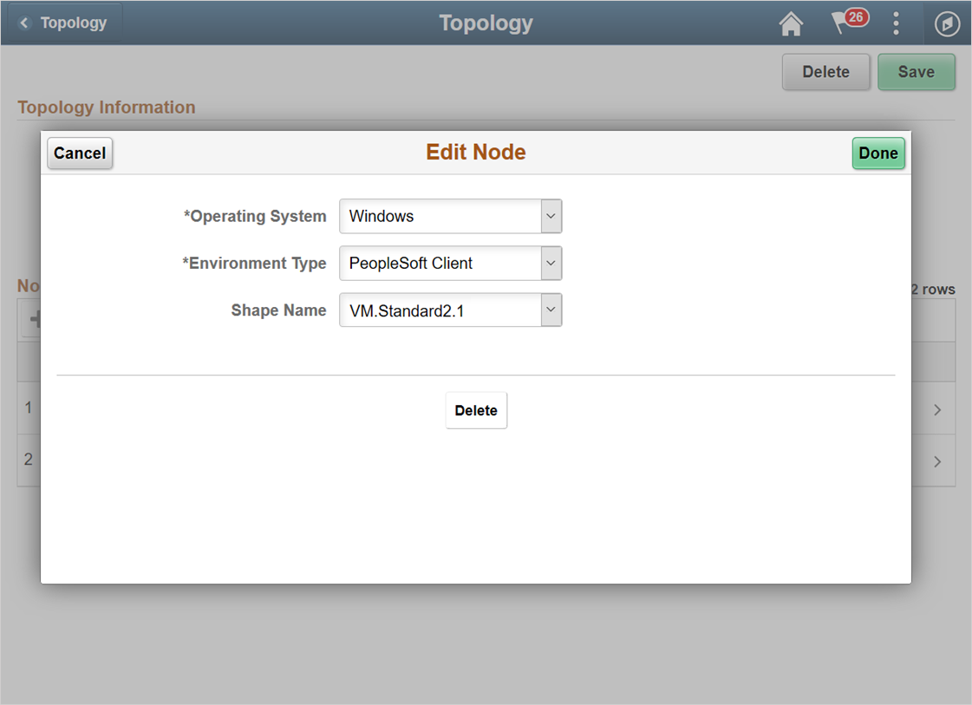

1. When you are ready, Click Save. The topology should now look as shown below.

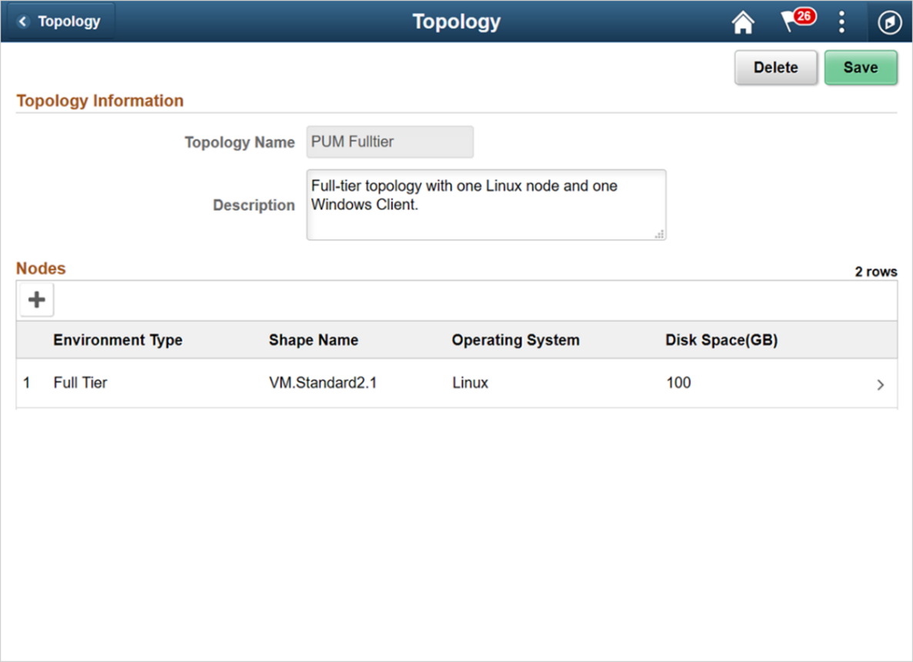

## Create a new Environment Template

Time: 10 mins

1. Navigate to Dashboard | Environment Template. Click Add New Template button. Provide below details and click Next.

|  |  |
| --- | --- |
| Name | MYPUM |
| Description | Test a PUM image |
| Database | Click on Search icon and select a downloaded DPK. For example. PEOPLESOFT HCM UPDATE IMAGE 9.2.030 - NATIVE OS |

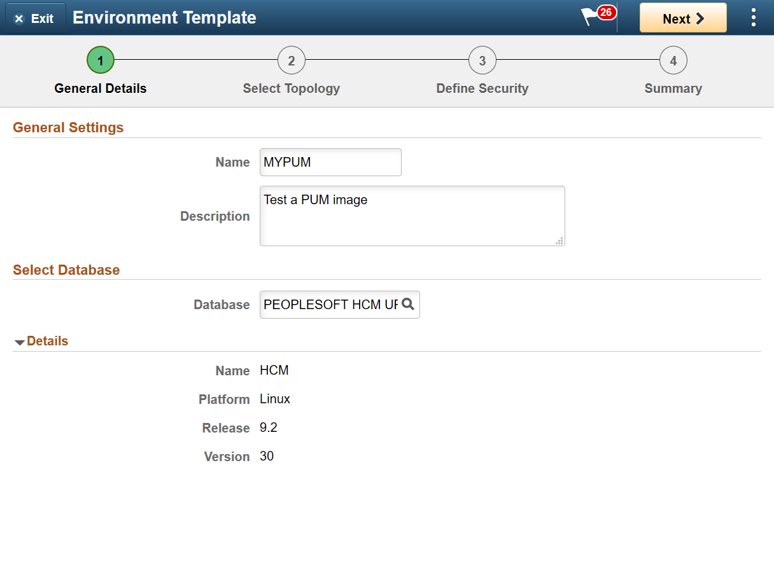

1. On Select Topology page, click on search icon to search for a topology and select the PUM Fulltier topology.

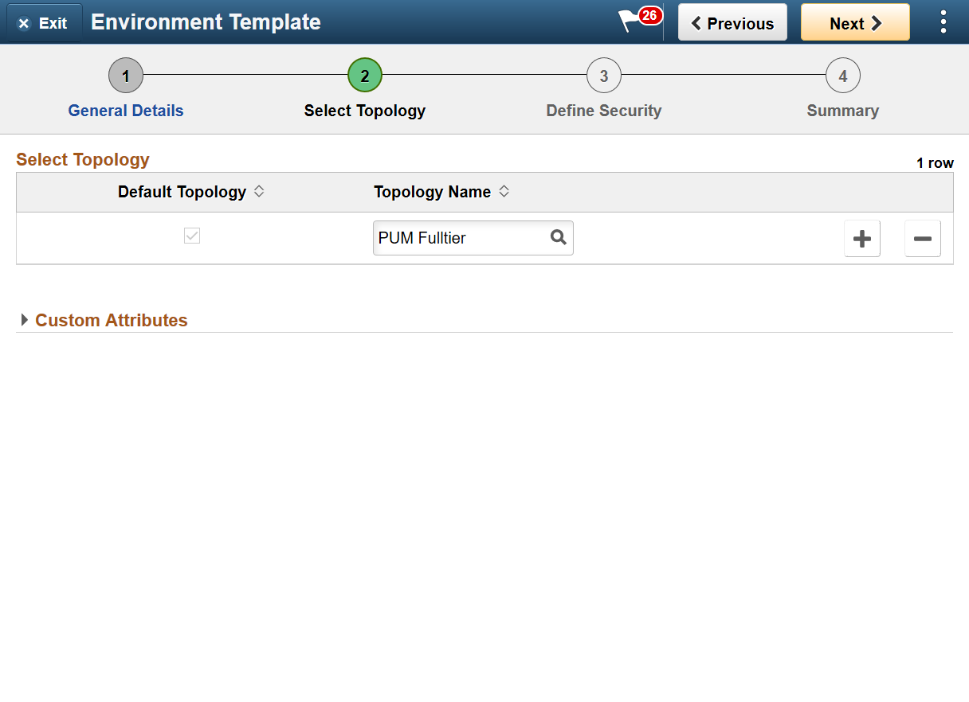

1. Expand the Custom Attributes and select the PUM Fulltier topology and click Edit Custom Attributes.

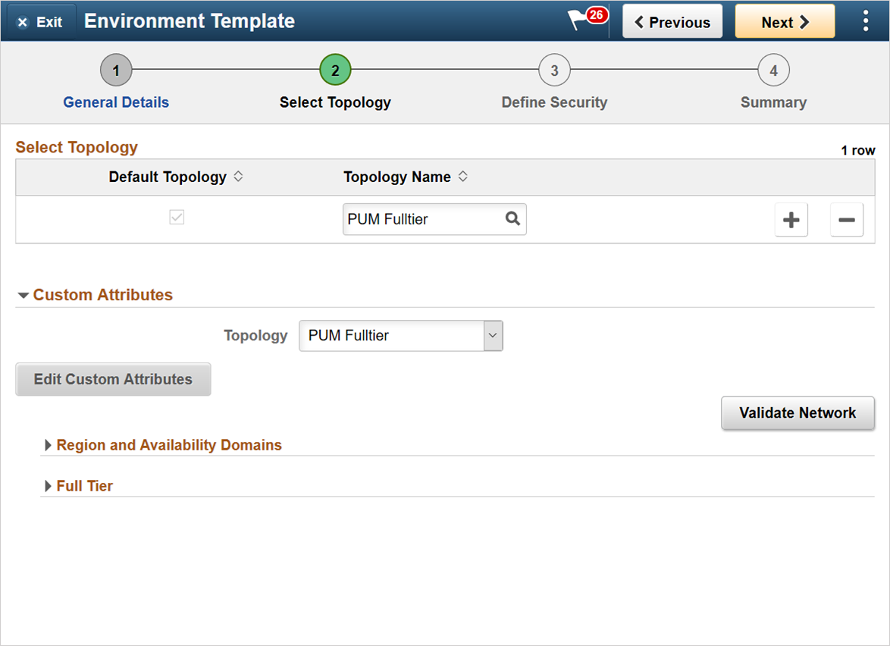

1. Expand the Region and Availability Domains section. Select the Region and Availability Domain in which Cloud Manager instance is not deployed. Refer Appendix A to review tenancy service limits and find the AD which has the required shape available for provisioning. In this exercise, for trial accounts, AD 2 should have the required shapes. Also refer to Appendix C for network topology.

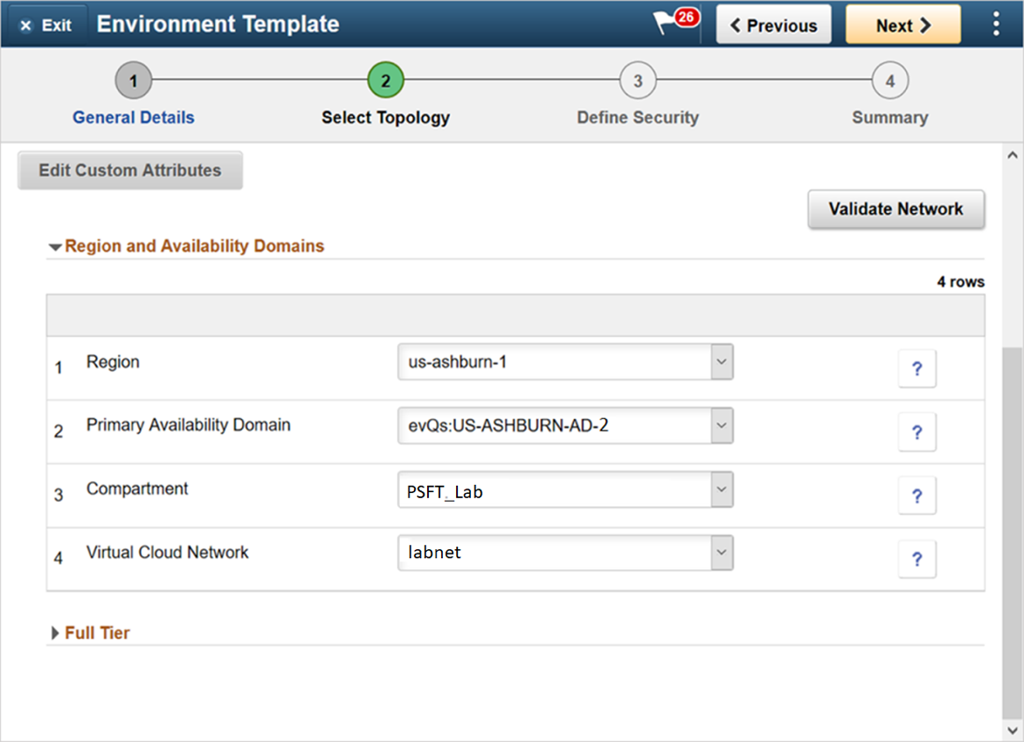

**Regional and Availability Domains**

|  |  |  |
| --- | --- | --- |
| 1 | Region | us-ashburn-1 |
| 2 | Primary Availability Domain | evQs:US-ASHBURN-AD-2  **(Select an AD 2, where shapes are available for use)** |
| 3 | Compartment | PSFT_Lab |
| 4 | Virtual Cloud Network | Labnet |

1. Expand each of the sub-sections under Full Tier and PeopleSoft Client and provide inputs. The defaults for many parameters can be changed optionally.

[**Full Tier**](javascript:toggleGroup('win0divECL_CUST_SP_WRK_ECL_GROUPBOX1$0','ECL_CUST_SP_WRK_ECL_GROUPBOX1$0');) **|** [**General Settings**](javascript:toggleGroup('win0divECL_CUST_SP_WRK_ECL_GROUPBOX9$0','ECL_CUST_SP_WRK_ECL_GROUPBOX9$0');)

|  |  |  |
| --- | --- | --- |
| 1 | PeopleSoft Deployment Path | /u01/app/oracle/product |
| 2 | Database Access Id | SYSADM |
| 3 | Database Connect Id | people |
| 4 | Enable EM agent | No |
| 5 | Weblogic Administrator Username | system |
| 6 | Database Name | MYPUM |
| 7 | Gateway Administrator Username | administrator |
| 8 | Database Operator Id | PS |
| 9 | Database Server Port | 1522 |
| 10 | Database Type | SYS |
| 11 | Enable Multi Language | NO |
| 12 | Pre Provision Custom Script | - |
| 13 | Post Provision Custom Script | - |

**Full Tier |** [**Subnet Settings**](javascript:toggleGroup('win0divECL_CUST_SP_WRK_ECL_GROUPBOX9$1','ECL_CUST_SP_WRK_ECL_GROUPBOX9$1');)

|  |  |  |
| --- | --- | --- |
| 1 | Subnet For Primary Instance | Select a subnet. E.g. envs |

Note – Since there is only one subnet, the ‘envs’ subnet is automatically chosen when AD2, PSFT_Lab compartment and labnet VCN is chosen in the earlier section.

**Full Tier |** [**Domain Settings**](javascript:toggleGroup('win0divECL_CUST_SP_WRK_ECL_GROUPBOX10$0','ECL_CUST_SP_WRK_ECL_GROUPBOX10$0');) **|** [**Web Server Settings**](javascript:toggleGroup('win0divECL_CUST_SP_WRK_ECL_GROUPBOX9$97$$0','ECL_CUST_SP_WRK_ECL_GROUPBOX9$97$$0');)

|  |  |  |
| --- | --- | --- |
| 1 | Number of Domains | 1 |
| 2 | Authentication Domain | default |
| 3 | HTTP PIA Port | 8000 |
| 4 | HTTPS PIA Port | 8443 |

**Full Tier |** [**Domain Settings**](javascript:toggleGroup('win0divECL_CUST_SP_WRK_ECL_GROUPBOX10$0','ECL_CUST_SP_WRK_ECL_GROUPBOX10$0');) **|** [**Appserver Settings**](javascript:toggleGroup('win0divECL_CUST_SP_WRK_ECL_GROUPBOX9$97$$1','ECL_CUST_SP_WRK_ECL_GROUPBOX9$97$$1');)

|  |  |  |
| --- | --- | --- |
| 1 | Number of Domains | 1 |
| 2 | Number of App Server Instance (PSAPPSRV services) Per Domain | 2 |
| 3 | Number of Query Server Instances(PSQRYSRV services) Per Domain | 1 |
| 4 | Number of SQL Access App Server(PSSAMSRV services) Per Domain | 1 |
| 5 | Number of Jolt Listener(Jolt Handler) Per Domain | 3 |
| 6 | Jolt Port | 9033 |
| 7 | WSL Port | 7000 |
| 8 | Enable IB settings on first domain | YES |
| 9 | Number of App Server instance(PSAPPSRV services) for IB | 2 |
| 10 | Number of SQL Access App Server(PSSAMSRV services) for IB | 1 |
| 11 | Number of PSBRKHND instances for IB | 1 |
| 12 | Number of PSSUBHND instances for IB | 1 |
| 13 | Number of PSPUBHND instances for IB | 1 |

**Full Tier |** [**Domain Settings**](javascript:toggleGroup('win0divECL_CUST_SP_WRK_ECL_GROUPBOX10$0','ECL_CUST_SP_WRK_ECL_GROUPBOX10$0');) **|** [**Process Scheduler Settings**](javascript:toggleGroup('win0divECL_CUST_SP_WRK_ECL_GROUPBOX9$97$$2','ECL_CUST_SP_WRK_ECL_GROUPBOX9$97$$2');)

|  |  |  |
| --- | --- | --- |
| 1 | Number of Domains | 1 |
| 2 | Number of App Engine Server Instances(PSAESRV services) Per Domain | 2 |
| 3 | Number of App Engine Server Instances(PSDSTSRV services) Per Domain | 2 |

**Full Tier |** [**Domain Settings**](javascript:toggleGroup('win0divECL_CUST_SP_WRK_ECL_GROUPBOX10$0','ECL_CUST_SP_WRK_ECL_GROUPBOX10$0');) **|** [**Process Scheduler Server Definition Parameters**](javascript:toggleGroup('win0divECL_CUST_SP_WRK_ECL_GROUPBOX9$97$$3','ECL_CUST_SP_WRK_ECL_GROUPBOX9$97$$3');)

|  |  |  |
| --- | --- | --- |
| 1 | Application Engine | 1 |
| 2 | XML Publisher | 1 |
| 3 | COBOL SQL | 1 |
| 4 | Optimization Engine | 1 |
| 5 | SQR Process | 1 |
| 6 | SQR Report | 1 |
| 7 | Max Api Aware | 1 |

**Full Tier |** [**Domain Settings**](javascript:toggleGroup('win0divECL_CUST_SP_WRK_ECL_GROUPBOX10$0','ECL_CUST_SP_WRK_ECL_GROUPBOX10$0');) **|** [**Advanced**](javascript:toggleGroup('win0divECL_CUST_SP_WRK_ECL_GROUPBOX3$0','ECL_CUST_SP_WRK_ECL_GROUPBOX3$0');)

None

1. Click Next to configure zone and role. Select options as shown below.

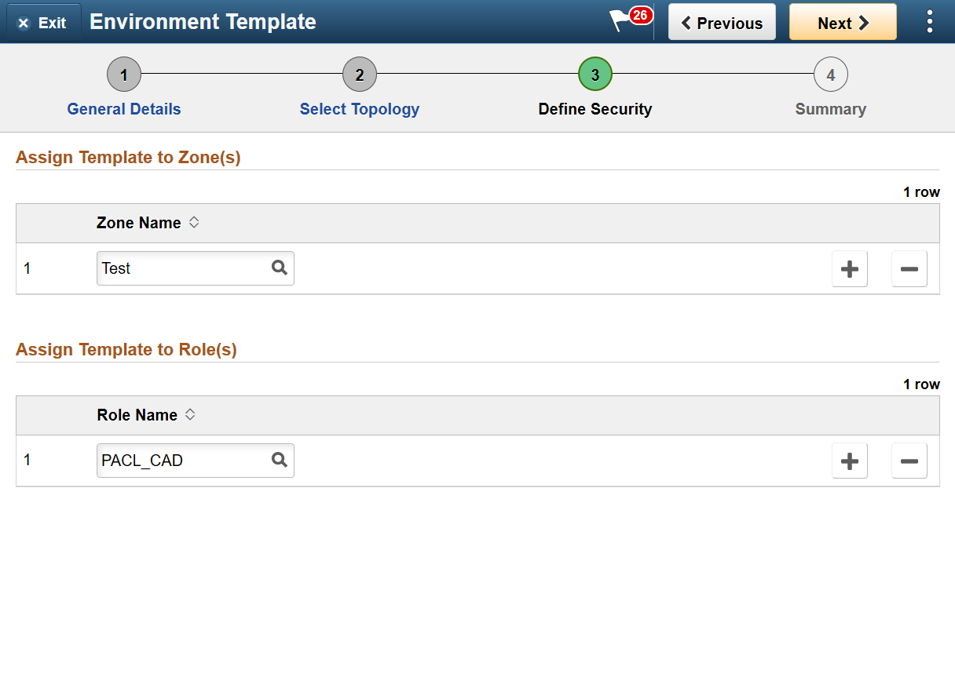

1. Click Next. Review the page and click Submit to save the template.

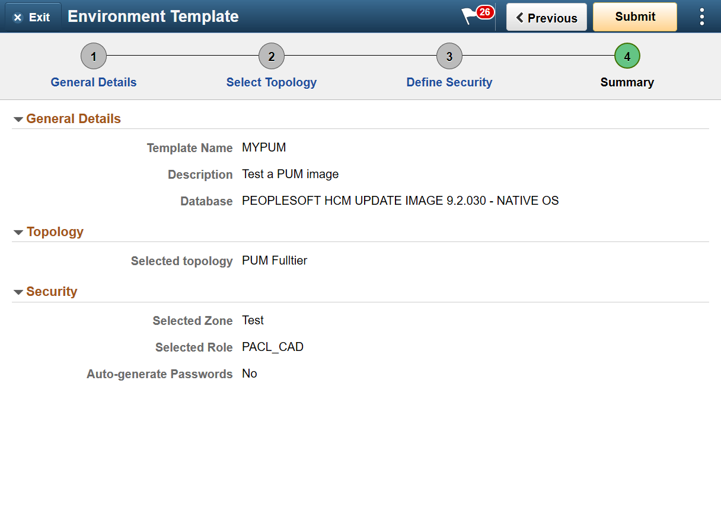

## Create Environment

Time: 50 mins

1. Navigate to Dashboard | Environments. Click Create Environment button.
2. Provide a unique environment name. Select the Template that was created in previous section – MYPUM. Expand all sections under Environment Attributes and provide all inputs. Use the table given below for quick and default values. Click Done to begin the environment provisioning process.

Monitor the deployment logs under Dashboard | Environments | <Environment> | Action Menu | Details | Logs

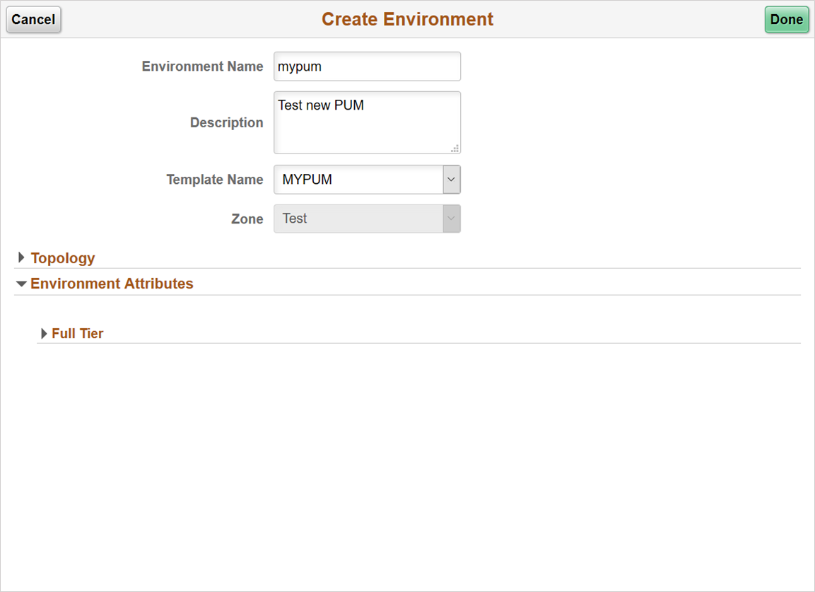

[**Full Tier**](javascript:toggleGroup('win0divECL_CUST_SP_WRK_ECL_GROUPBOX1$0','ECL_CUST_SP_WRK_ECL_GROUPBOX1$0');) | [**Credentials**](javascript:toggleGroup('win0divECL_CUST_SP_WRK_ECL_GROUPBOX2$0','ECL_CUST_SP_WRK_ECL_GROUPBOX2$0');)

|  |  |  |
| --- | --- | --- |
|  | **Name** | **Value** |
| 1 | Database Connect Id | people |
| 2 | Database Connect Password | Password1234 |
| 3 | Weblogic Administrator Username | system |
| 4 | Weblogic Administrator Password | Password1234 |
| 5 | Database Administrator Password | Password1234 |
| 6 | Gateway Administrator Username | administrator |
| 7 | Gateway Administrator Password | Password1234 |
| 8 | Database Operator Id | PS |
| 9 | Database Operator Password | PS |
| 10 | Web Profile Password for user PTWEBSERVER | Password1234 |
| 11 | Database Access Id | SYSADM |
| 12 | Database Access Password | Password1234 |

[**Full Tier**](javascript:toggleGroup('win0divECL_CUST_SP_WRK_ECL_GROUPBOX1$0','ECL_CUST_SP_WRK_ECL_GROUPBOX1$0');) **|** [**General Settings**](javascript:toggleGroup('win0divECL_CUST_SP_WRK_ECL_GROUPBOX9$0','ECL_CUST_SP_WRK_ECL_GROUPBOX9$0');)

|  |  |  |
| --- | --- | --- |
| 1 | PeopleSoft Deployment Path | /u01/app/oracle/product |
| 2 | Database Access Id | SYSADM |
| 3 | Database Connect Id | people |
| 4 | Enable EM agent | No |
| 5 | Weblogic Administrator Username | system |
| 6 | Database Name | MYPUM |
| 7 | Gateway Administrator Username | administrator |
| 8 | Database Operator Id | PS |
| 9 | Database Server Port | 1522 |
| 10 | Database Type | SYS |
| 11 | Enable Multi Language | NO |
| 12 | Pre Provision Custom Script | - |
| 13 | Post Provision Custom Script | - |

|  |
| --- |
|  |

**Full Tier |** [**Domain Settings**](javascript:toggleGroup('win0divECL_CUST_SP_WRK_ECL_GROUPBOX10$0','ECL_CUST_SP_WRK_ECL_GROUPBOX10$0');) **|** [**Web Server Settings**](javascript:toggleGroup('win0divECL_CUST_SP_WRK_ECL_GROUPBOX9$97$$0','ECL_CUST_SP_WRK_ECL_GROUPBOX9$97$$0');)

|  |  |  |
| --- | --- | --- |
| 1 | Number of Domains | 1 |
| 2 | Authentication Domain | default |
| 3 | HTTP PIA Port | 8000 |
| 4 | HTTPS PIA Port | 8443 |

**Full Tier |** [**Domain Settings**](javascript:toggleGroup('win0divECL_CUST_SP_WRK_ECL_GROUPBOX10$0','ECL_CUST_SP_WRK_ECL_GROUPBOX10$0');) **|** [**Appserver Settings**](javascript:toggleGroup('win0divECL_CUST_SP_WRK_ECL_GROUPBOX9$97$$1','ECL_CUST_SP_WRK_ECL_GROUPBOX9$97$$1');)

|  |  |  |
| --- | --- | --- |
| 1 | Number of Domains | 1 |
| 2 | Number of App Server Instance (PSAPPSRV services) Per Domain | 2 |
| 3 | Number of Query Server Instances(PSQRYSRV services) Per Domain | 1 |
| 4 | Number of SQL Access App Server(PSSAMSRV services) Per Domain | 1 |
| 5 | Number of Jolt Listener(Jolt Handler) Per Domain | 3 |
| 6 | Jolt Port | 9033 |
| 7 | WSL Port | 7000 |
| 8 | Enable IB settings on first domain | YES |
| 9 | Number of App Server instance(PSAPPSRV services) for IB | 2 |
| 10 | Number of SQL Access App Server(PSSAMSRV services) for IB | 1 |
| 11 | Number of PSBRKHND instances for IB | 1 |
| 12 | Number of PSSUBHND instances for IB | 1 |
| 13 | Number of PSPUBHND instances for IB | 1 |

**Full Tier |** [**Domain Settings**](javascript:toggleGroup('win0divECL_CUST_SP_WRK_ECL_GROUPBOX10$0','ECL_CUST_SP_WRK_ECL_GROUPBOX10$0');) **|** [**Process Scheduler Settings**](javascript:toggleGroup('win0divECL_CUST_SP_WRK_ECL_GROUPBOX9$97$$2','ECL_CUST_SP_WRK_ECL_GROUPBOX9$97$$2');)

|  |  |  |
| --- | --- | --- |
| 1 | Number of Domains | 1 |
| 2 | Number of App Engine Server Instances(PSAESRV services) Per Domain | 2 |
| 3 | Number of App Engine Server Instances(PSDSTSRV services) Per Domain | 2 |

**Full Tier |** [**Domain Settings**](javascript:toggleGroup('win0divECL_CUST_SP_WRK_ECL_GROUPBOX10$0','ECL_CUST_SP_WRK_ECL_GROUPBOX10$0');) **|** [**Process Scheduler Server Definition Parameters**](javascript:toggleGroup('win0divECL_CUST_SP_WRK_ECL_GROUPBOX9$97$$3','ECL_CUST_SP_WRK_ECL_GROUPBOX9$97$$3');)

|  |  |  |
| --- | --- | --- |
| 1 | Application Engine | 1 |
| 2 | XML Publisher | 1 |
| 3 | COBOL SQL | 1 |
| 4 | Optimization Engine | 1 |
| 5 | SQR Process | 1 |
| 6 | SQR Report | 1 |
| 7 | Max Api Aware | 1 |

**Full Tier |** [**Domain Settings**](javascript:toggleGroup('win0divECL_CUST_SP_WRK_ECL_GROUPBOX10$0','ECL_CUST_SP_WRK_ECL_GROUPBOX10$0');) **|** [**Advanced**](javascript:toggleGroup('win0divECL_CUST_SP_WRK_ECL_GROUPBOX3$0','ECL_CUST_SP_WRK_ECL_GROUPBOX3$0');)

None

## Additional Exercise – Provision Environments with Windows Clients

As a take home exercise, you can provision a PeopleSoft environment with a Windows client node. Follow the high level steps outlined below.

1. Remove the PUM topology from the Environment Template that was used to provision in the previous section – Refer step 2 in Create a New Environment Template
2. Edit the PUM topology and add a new Windows Client node. Select an available shape. Refer step 1in Review and Update a Topology. Hint - Click + to add a node.
3. Edit the Environment Template and re-add the PUM topology – Refer step 2 in Create a New Environment Template. Hint - Search for PUM topology.
4. Configure the Custom Attributes of the topology in the template. Ensure to select the Availability Domain which has the required shapes – Refer Step 3 in Create a New Environment Template
5. Create a new Environment using the newly modified template – Refer Create Environment.

## Appendix A – OCI Account URL and Resources

The OCI Console URL will be as shown in the screenshot below. The standard format is – https://myservices-<account_name>.console.oraclecloud.com. In this example, the account name provided during account creation is ‘nkpsftcloud’. The URL will be <https://myservices-nkpsftcloud.console.oraclecloud.com>.

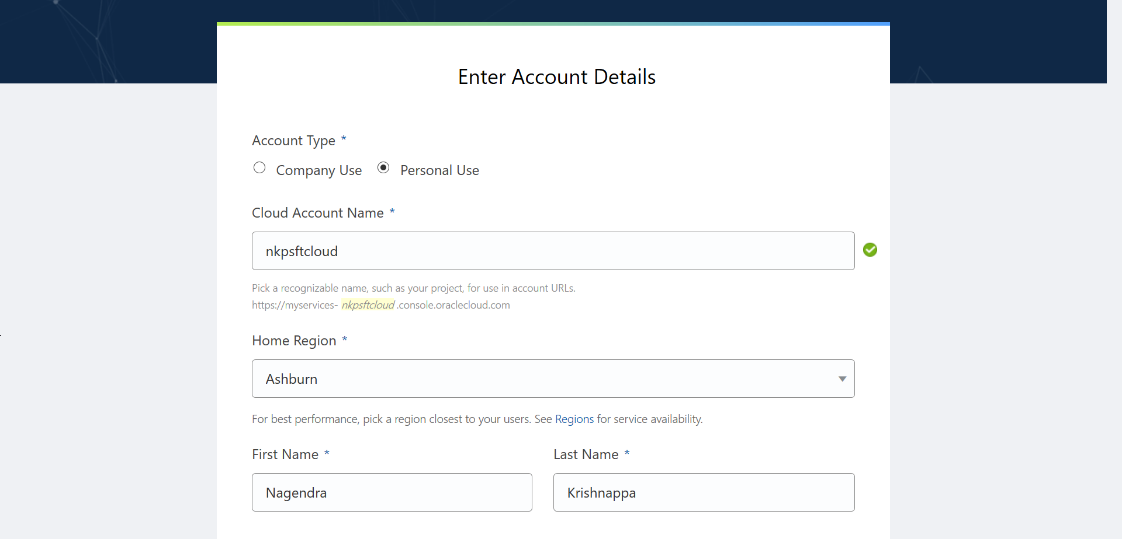

Review the resources available in your tenancy. Navigate to Menu 🡪 Administration 🡪 Tenancy Details and review the service limits for Compute. Determine the number of VM shapes available in your tenancy.

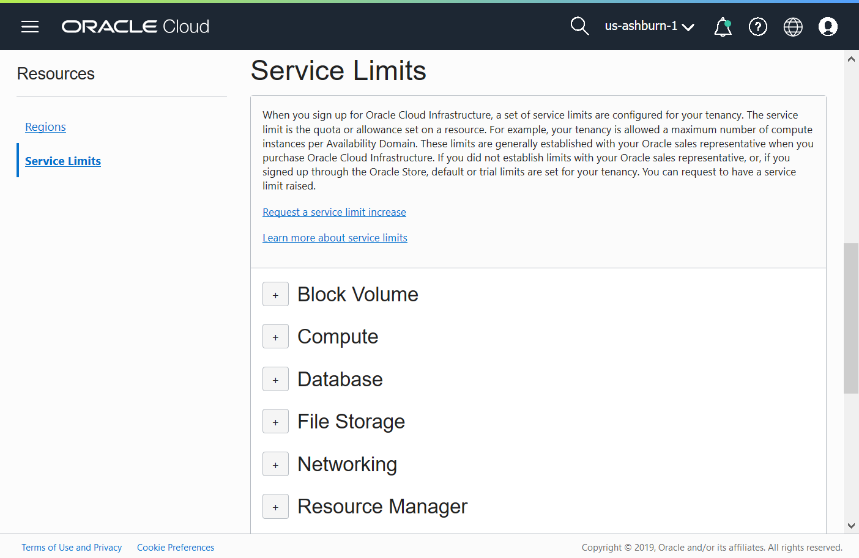

Your tenancy should have the following shapes.

|  |  |  |  |
| --- | --- | --- | --- |
| Shape | AD-1 | AD-2 | AD-3 |
| VM.Standard2.1 | 1 | 1 | 1 |
| VM.Standard2.2 | 1 | 1 | 1 |
| VM.Standard.E2.1 | 1 | 1 | 1 |
| VM.Standard.E2.2 | 1 | 1 | 1 |

## Appendix B – Accessing Cloud Manager using SSH

Steps to SSH into Cloud Manager instance.

1. SSH key pair required to access Cloud Manager instance was created in step 6 in section 6.
2. The SSH key pair will be under the folder named ‘keys’, in the same folder where the psftcm-setup.zip was extracted.



1. Launch Git Bash and navigate to the keys folder.
2. Retrieve the Cloud Manager IP address. It was provided as output when the stack was applied.

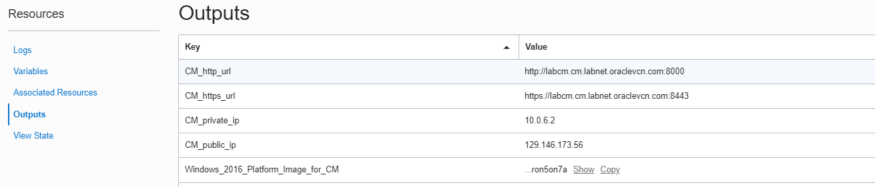

1. SSH into the Cloud Manager instance using below command.

|  |
| --- |
| $ ssh -i id_rsa [opc@129.213.145.213](mailto:opc@129.213.145.213) |

## Appendix C – Network layout

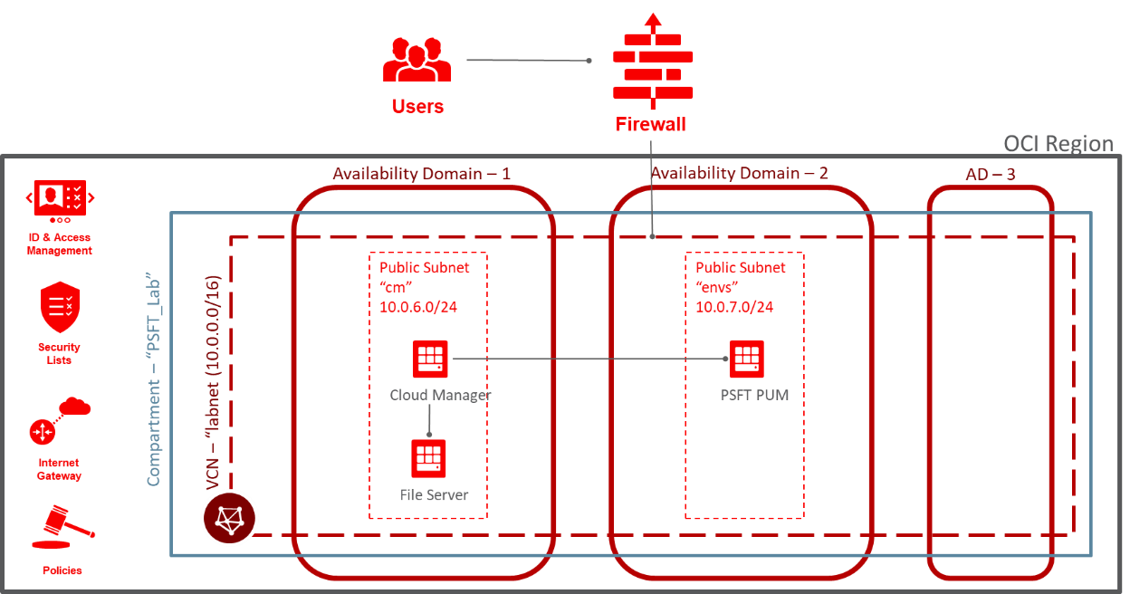

## Appendix D – Deployed OCI Resources

The deployment automation (Resource Manager Stack) provisions numerous resources in the tenancy. To find the list of resources that were created, navigate to OCI console 🡪 Resource Manager 🡪 Stacks 🡪 <Stack> 🡪 Apply Job details. On this page, click Associated Resources under Resources.

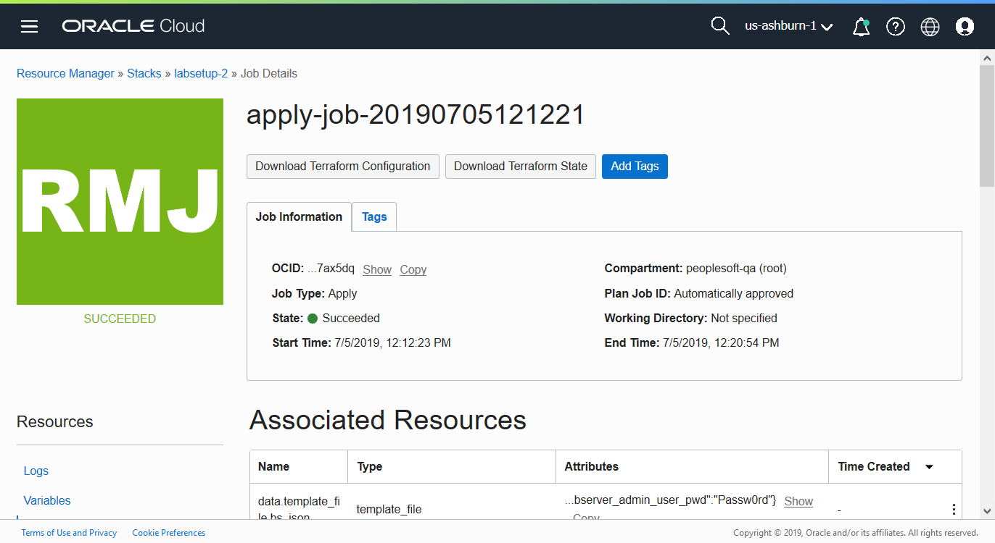

In this lab example, the Associated Resources show all the newly created resources.

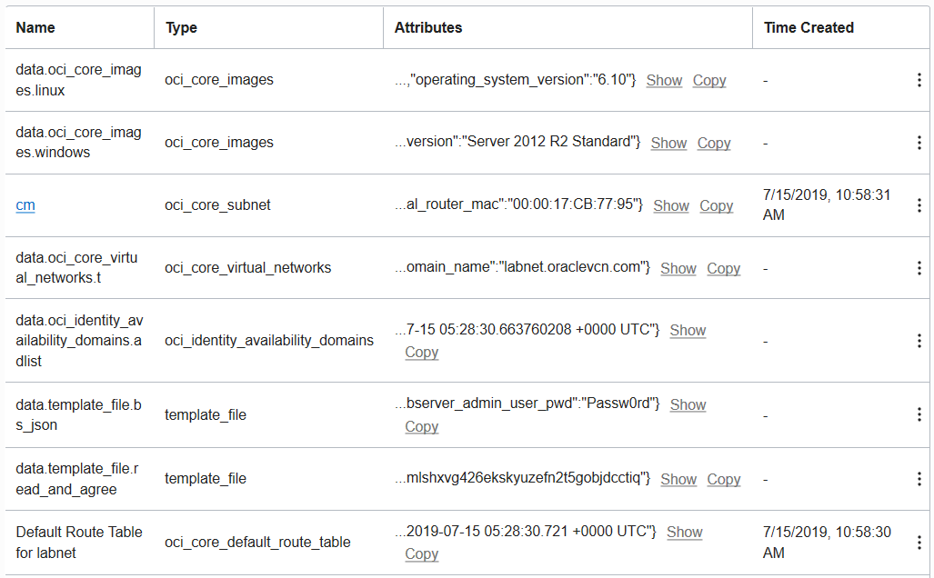

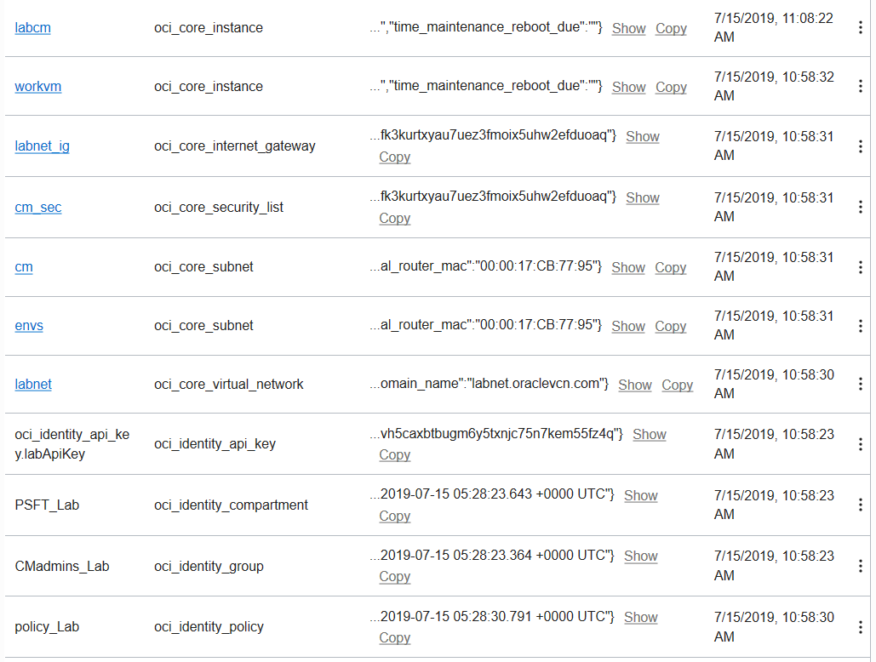

## Appendix E – Provisioning Windows Instances

In this lab exercise, Windows node was removed from the topology to keep the provisioning process short and simple. If you want to provision Windows instances as part of an environment at a later point in time, you can do so easily.

## Appendix F – Creating a new subnet

1. Navigate to Menu 🡪 Networking 🡪 Virtual Cloud Networks. Set the Compartment to ‘PSFT_Lab’. Click on the existing VCN “labnet”.

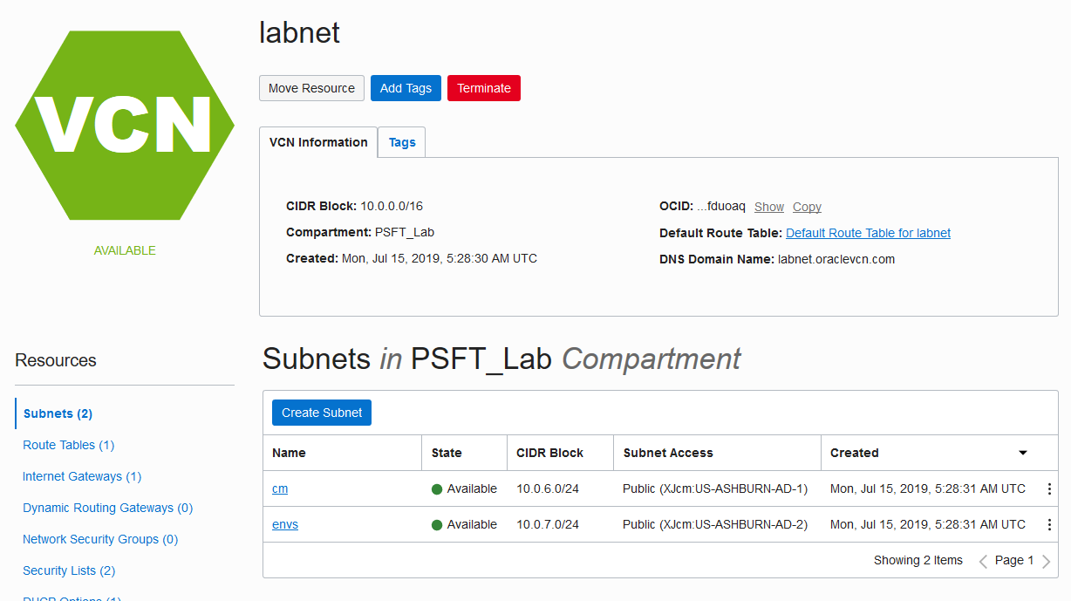

1. Click on Create Subnet button to add a new subnet. Use default route table, and default DHCP options. Use 10.0.8.0/24 as the CIDR for subnet.

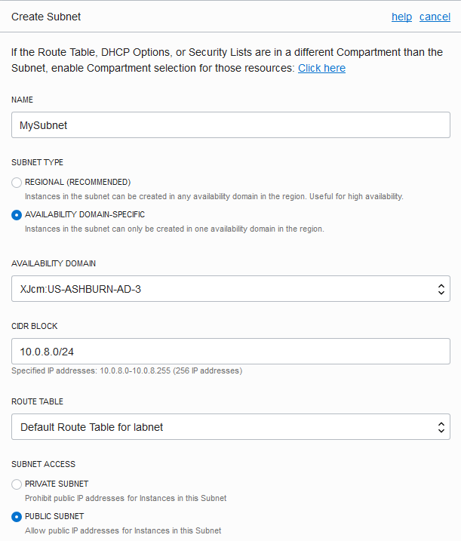

|  |  |
| --- | --- |
| **Attribute** | **Value** |
| Name | MySubnet |
| Subnet Type | Availability Domain-specific |
| Availability Domain | AD 3 |
| CIDR Block | 10.0.8.0/24 |
| Route Table | Default Route Table for labnet |
| Subnet Access | Public Subnet |
| DNS Resolution | Enable Use DNS hostnames in this SUBNET |
| Security List | Add two security lists using the button + Additional Security List as shown in below screenshot –   1. cm_sec 2. Default Security List for labnet |

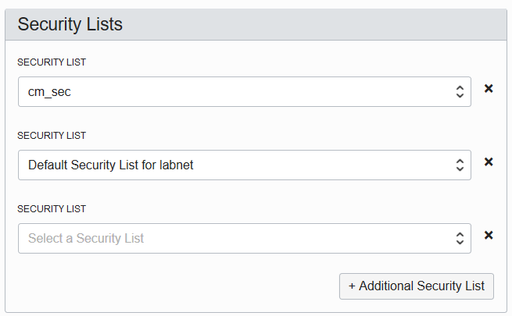

1. Click Create Subnet. The newly created subnet will be as shown

